Sean Lee

Professor Imielinski

CS 336

3 October 2022

1. Drinkers who like the most beers (highest number of beers)

SELECT DISTINCT drinker, COUNT(beer)

FROM Likes group by drinker ORDER BY COUNT(beer) DESC;

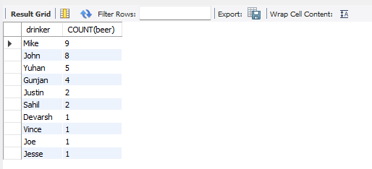

1. Bars which sell most expensive Budweiser and are not frequented by Gunjan

SELECT DISTINCT s.beer, s.price, s.bar

FROM (Sells s, Frequents f)

WHERE s.beer='Budweiser' AND f.bar=s.bar AND f.drinker!='Gunjan' AND 0=

(

SELECT count(*)

FROM Sells s1

WHERE s1.price > s.price and s1.beer='Budweiser'

) ;

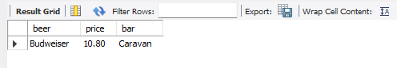

1. Drinkers who frequent only bars which serve all beers they like

SELECT DISTINCT Likes.drinker

FROM Likes

INNER JOIN Frequents

ON Frequents.drinker=Likes.drinker

INNER JOIN Sells

ON Sells.beer=Likes.beer AND Sells.bar=Frequents.bar;

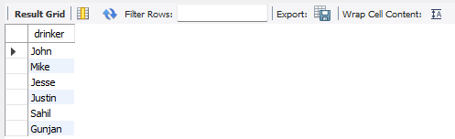

1. Drinkers who frequent most popular bar (the one with highest count of drinkers)

SELECT DISTINCT drinker

From Frequents AS f1

JOIN

(

SELECT bar

FROM Frequents GROUP BY bar ORDER BY COUNT(drinker) DESC

LIMIT 1

) AS f2

ON f1.bar

IN (f2.bar);

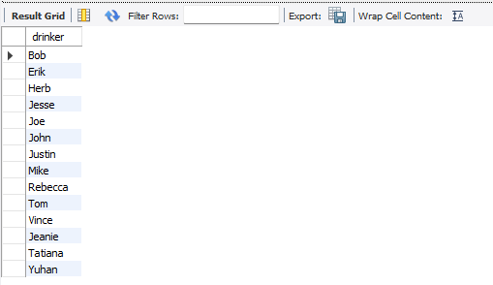

1. Precinct(s) which collected the least number of total votes by end of day of November 5th 2020

SELECT precinct, totalvotes

FROM Penna

WHERE Timestamp='2020-11-04 04:07:12'

ORDER BY totalvotes ASC LIMIT 20;

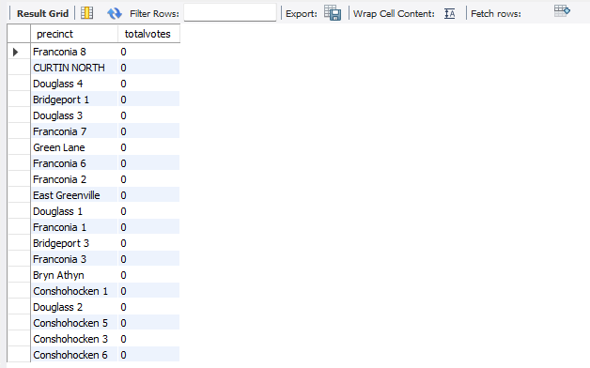

1. Which precincts did Trump win by more than 100 votes in 2020

SELECT precinct, Biden, Trump

FROM Penna

WHERE (Trump - Biden) > 100;

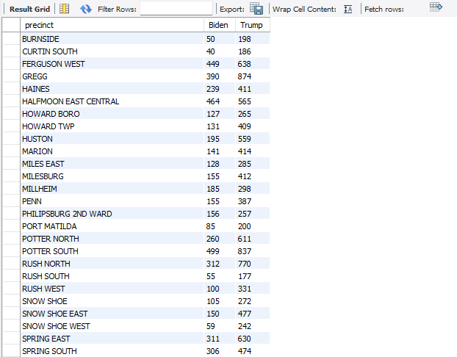

1. Has Trump ever led the total vote (for any of the timestamps)? (Return "Yes he did on <timestamp>" or "No he never did".

SELECT CONCAT('Yes he did on <', Timestamp, '>') AS Did_Trump_ever_lead_the_total_vote

From Penna

WHERE Trump > Biden;

